7.Perform basic video processing operations on the captured video. Read captured video in python and display the video, in slow motion and in fast motion.

**AIM:**

To read an image and convert it to grayscale using OpenCV in Python.

**PROCEDURE:**

1. Install OpenCV (if not already installed):install opencv-python
2. Import required libraries
3. Read the image
4. Convert the image to grayscale
5. Display the images
6. Wait for a key press & close windows

**PROGRAM:**

import cv2

image = cv2.imread("sample.jpg") # Replace 'sample.jpg' with your image path

gray_image = cv2.cvtColor(image, cv2.COLOR_BGR2GRAY)

cv2.imshow("Original Image", image)

cv2.imshow("Grayscale Image", gray_image)

cv2.waitKey(0)

cv2.destroyAllWindows()

**INPUT:**

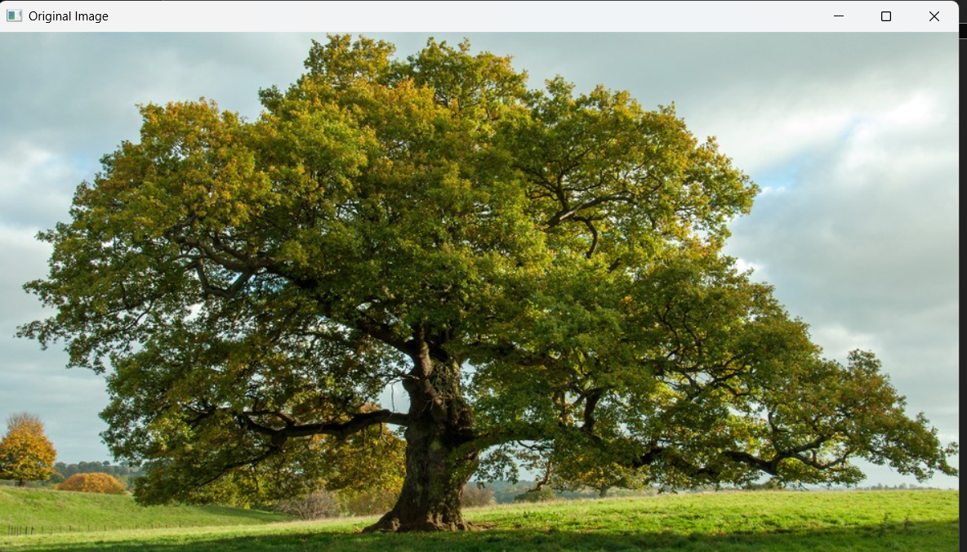

**OUTPUT:**

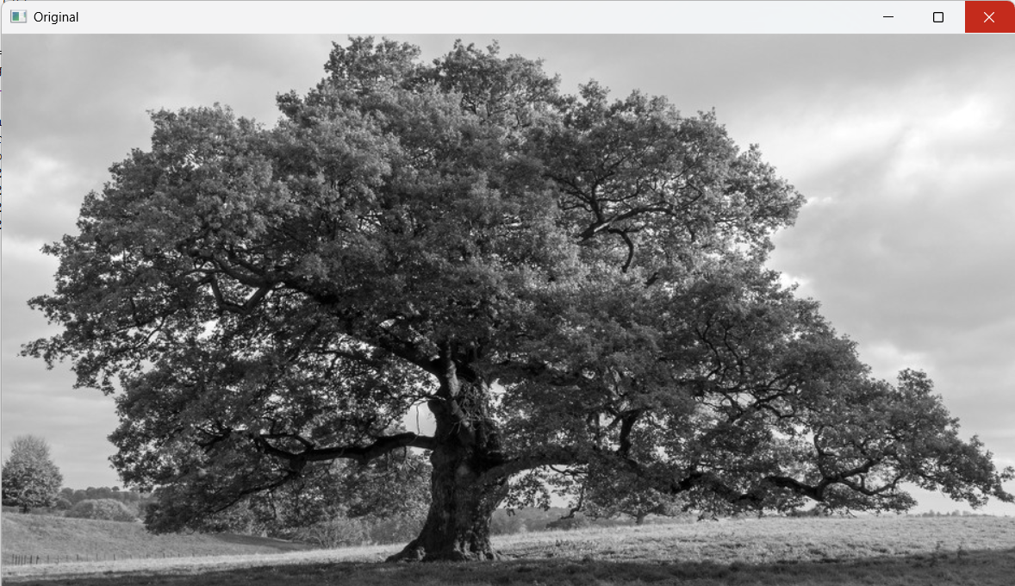

n

**RESULT :**

Successfully read the input image and converted it to grayscale using OpenCV in Python.